1: Smriti brought 8 boxes of sweets. Each box contains 2 sweets. How many sweets would be left with her after giving 10 sweets to friends? Help smriti by designing a Turing machine to find the remaining amount of sweets

Sol:

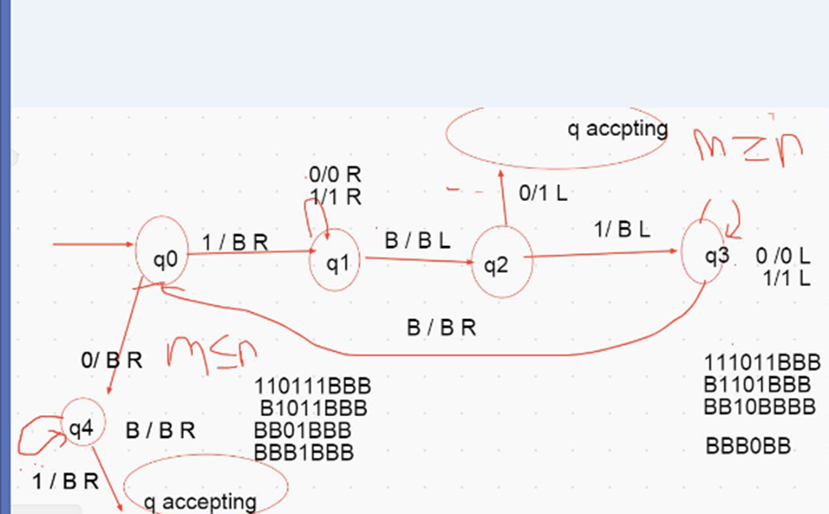

2: A Turing machine with doubly infinite tape is similar to an ordinary Turing machine, but its tape is infinite to the left as well as to the right. The tape is initially filled with blanks except for the portion that contains the input. Computation is defined as usual except that the head never encounters an end to the tape as it moves leftward. Show that this type of Turing machine recognizes the class of Turing-recognizable languages.

3: To organize graduation day ceremony in the University, volunteers are invited from student’s community. Equal number of boys and girls are selected to organize the event. Construct Turing machine with transition table or transition function that accepts only if the number of boys and girls in the organizing team is equal.

Sol: a^n b^n, n>=1